Referat fiabilitate – Eiffel

Grigore Eugen-Andrei  
Grupa 202

# Index

1. Instalare Eiffel 1

1.1 Instalare Locala 1

1.2 Instalare Docker 2

2. Exemplu “Hello Eiffel” 3

2.1 Creare Proiect 3

2.2 Compilare 4

2.3 Rulare program 5

2.4 Diagrama 6

3. Exemplu Hello Eiffel in Browser 7

3.1 Creare proiect 7

3.2 Compilare 11

3.3 Rulare 11

3.4 Diagrama 12

4. Generare documentatie 12

5. Testare in EiffelStudio 15

5.1 AutoTest 15

# Instalare Eiffel

## Instalare Locala

1. Descarcam installer-ul de pe pagina officiala

1. Urmarim pasii din wizard-ul de instalare

## Instalare Docker

# Exemplu “Hello Eiffel”

## Creare Proiect

## 2.2 Compilare



## 2.3 Rulare program

Rularea se face ca si a oricarui program, compilarea producand un executabil.

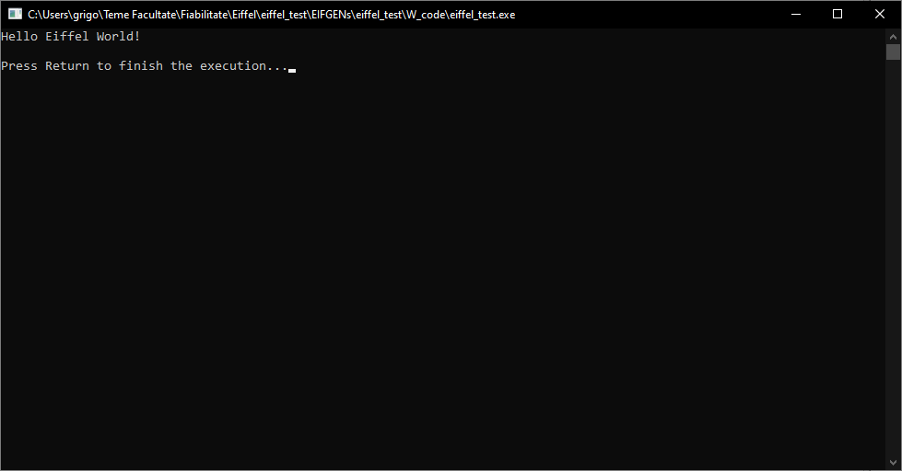

## 2.4 Diagrama

# Exemplu Hello Eiffel in Browser

## Creare proiect

## Compilare

## Rulare

Partea de rulare din pacate nu poate fi rulata. Am incercat sa ii fac troubleshoot dar in continuare nu a functionat.

## Diagrama

# Generare documentatie

# Testare in EiffelStudio

## 5.1 AutoTest

EiffelStudio are functionalitatea de AutoTest, care genereaza si ruleaza automat testele unitare. Pentru clasele Eiffel, AutoTest creeaza si ruleaza automat aceste teste.

* Generare test:

* Rezultate:

